SELECT ISNULL(IDENT_CURRENT('Instance'), 0) as CONTEO

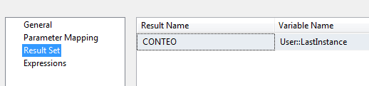

**The same as** SELECT MAX(InstanceID) from Instance